**Response to reviewers - TRLS-D-24-00289**

**Clinical trial results in context: comparison of baseline characteristics and outcomes of 38510 RECOVERY trial participants versus a reference population of 346271 people hospitalised with COVID-19 in England**

**Reviewer 1 –** ***“The authors performed a very nicely done analysis comparing patients included into the RECOVERY trial with the overall eligible population. Some questions remain and answering them might make the paper even more informative:”***

1. ***“The underrepresentation of females to me is the most striking finding. How was the RECOVERY trial regarding pregnancy in women of a childbearing age? Where they excluded? Was there a mandatory pregnancy testing which might be burdensome for clinicians? If not, are there any indicators that women of potentially childbearing age were more underrepresented than older ones? The broader picture could be mentioned in the discussion (https://pubmed.ncbi.nlm.nih.gov/37074073/;https://pubmed.ncbi.nlm.nih.gov/36539814/).”***

The RECOVERY trial allowed recruitment of women of childbearing age. Specific exclusions applied to some drugs and in some countries only. Further details of those exclusions can be found in the trial protocol, publicly available at <https://www.recoverytrial.net/>. The trial required did require a pregnancy test result to be entered for women of child-bearing potential. However, as shown in Supplementary Figure S1, the overall underrepresentation of women was due to underrepresentation of those aged >70, with slight overrepresentation of younger groups (including those of child-bearing potential). It is possible that this pattern is at least in part due to under-recruitment of older patients (who are more frequently women), in keeping with results from the references provided. These have been added to the discussion as suggested (page 13 of the revised manuscript with tracked changes), along with a mention of the possible impact of age.

1. ***“You found a lower mortality of trial participants for the first COVID wave. As you said, all acute care hospitals participated in the trial, but one might imagine that during the first wave there might have been a higher recruitment in large, tertiary centres with long trial experience. As the difference is driven by older patients might there be some referral bias to those centres depending on pre-existing morbidity? Those might have been better equipped for care or quicker to implement protocols. Is there any data on recruitment across levels of care over time?”***

The reviewer rightly outlines differences found in age and comorbidity profile between RECOVERY participants and the reference population, asking whether these could be due to higher recruitment from tertiary centres (with the assumption that these sites would be better equipped to conduct the study, and that older, multi-morbid patients would be less likely to be referred to those hospitals). While this is a reasonable assumption, investigating recruitment over time across different levels of care, and comparing such recruitment patterns in RECOVERY versus those in the reference population, would entail developing and performing a number of complex analyses which would delay publication of our study without drastically altering the interpretation of its results.

1. ***“You show striking differences in recruitment between different regions without mentioning them in the discussion. Do you have any idea what contributed to it? Is there any data that recruitment declined regionally depending on the overall health system load in that region over time?***

***It would be great if you could provide insight on any of those topics, but the manuscript should definitely be published in the journal anyhow.”***

Unfortunately, we have not been able to further investigate potential underlying reasons that justify differences in recruitment between different regions, and therefore have not expanded on this topic on our discussion. Nevertheless, it our belief that the finding that the regions most over-represented tended were some of those generally consider less affluent and with less funding (e.g. North East and South West, as oppose to London) support the idea that the streamlined and nationwide nature of the RECOVERY trial allowed participation of clinical and research teams (and patients) who would generally have less opportunities to do so.

It is possible that, as suggested, these could be due to different levels of health care system load in each region over time. However, many other factors could be at play, such as availability of research staff in a particular region or hospital. As above, unpicking such patterns in detail would require a number of complex analyses and collection of supplementary data, the results of such an endeavour are unlikely to meaningfully alter the overall interpretation of our results.

Nonetheless, we attach below a plot which was not included in the manuscript. This shows the proportion of individuals in each cohort (RECOVERY or reference population) within each age group and region over time. Although not designed to answer this particular question, this plot shows important variations over time for some regions (when considering not only the composition of each cohort, but also the difference between curves for both cohorts). However, the regions that are found to be overrepresented overall (as identified in Figure 2 in the main manuscript, i.e. North East, North West, East Midlands, East of England, South West, and South East) showed generally consistent overrepresentation overtime.

**Figure – Relative composition of the RECOVERY and the reference population cohorts over time, by age group and region**

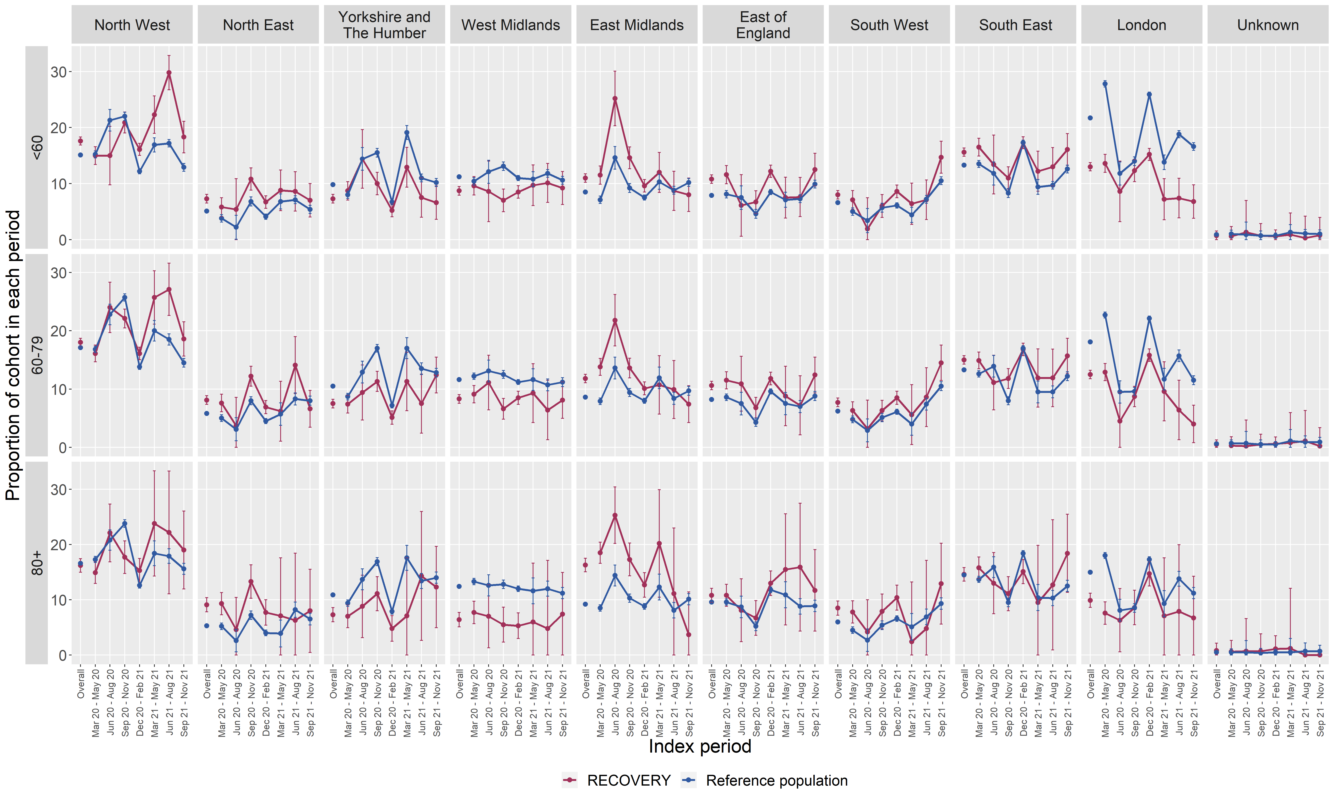

**Reviewer 2** – ***“This is an interesting manuscript by the authors comparing RECOVERY trial participants with a reference population hospitalized due to COVID-19 in England. The objectives, methods, and outcomes are presented clearly with appropriate introduction and discussion. I have no additional questions and only a minor comment on the technical error of the references where "Error! Reference source not found." appeared multiple times in the manuscript.”***

The incorrect cross­-references have been updated in the revised manuscript